**Presentation Consisting Of Graphs**

**Q1 - Major Reason People Getting Kidnap in Each and Every State.**

I Have taken the sample of Some States having the kidnapping reasons Marriage and Other Purposes.

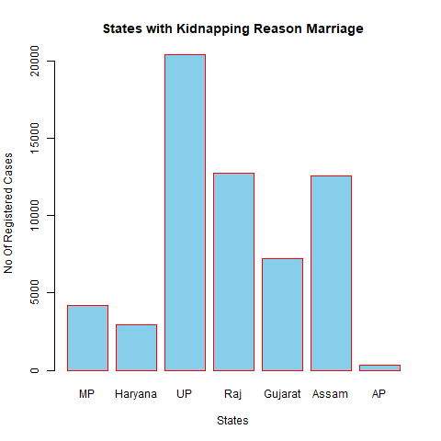

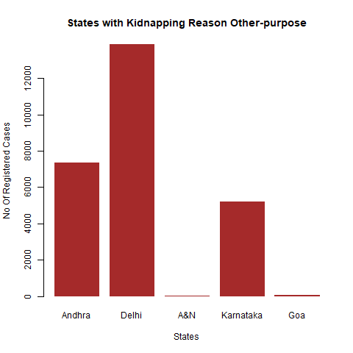

**Q2 - Offenders Relations to Rape Victim.**

If we look at the graph we will find that number of cases of rape in Rajasthan More than 7000 cases of rape in which Rappist are other known.

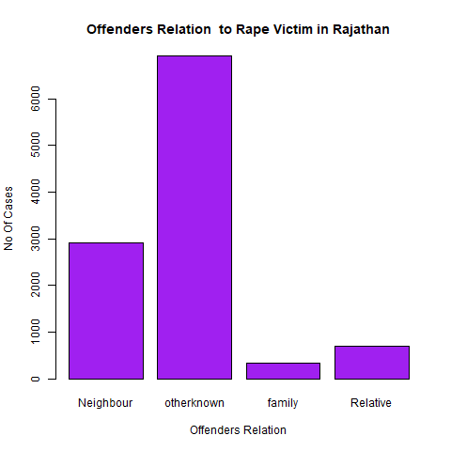

If we look at the graph we will find that number of cases of rape in Madhya Pradesh

Rappist are neighbour(>8500) and other known person(>12000).

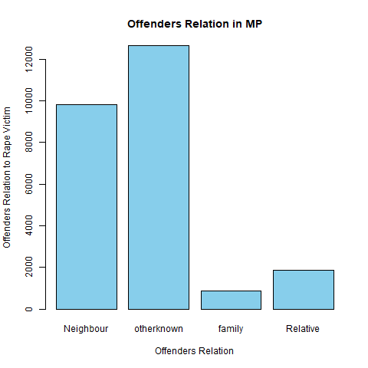

**Q3 - What is the family background , economic and education of juvenile offenders.**

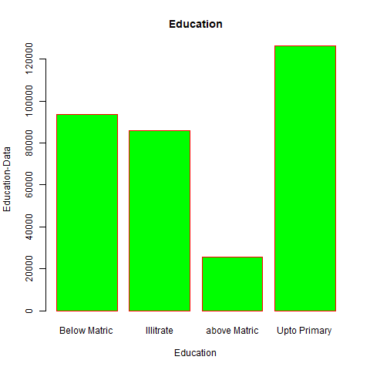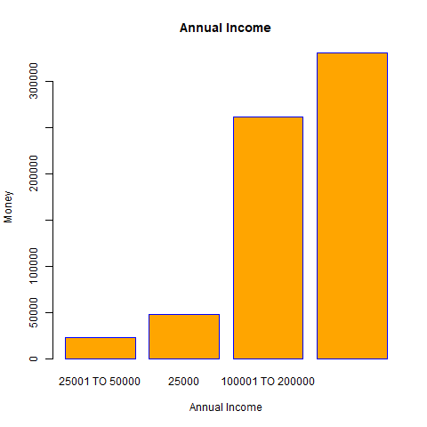

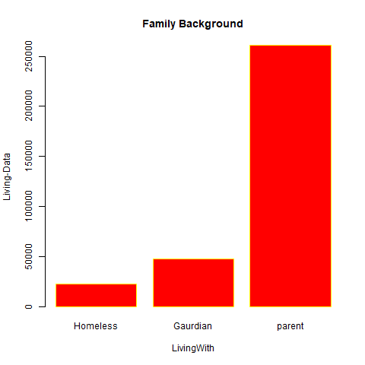

**Q4 - Which state has more crime against children and women.**

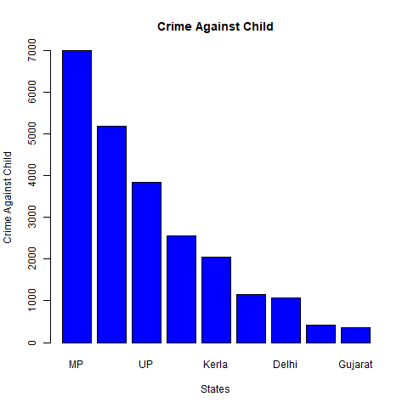

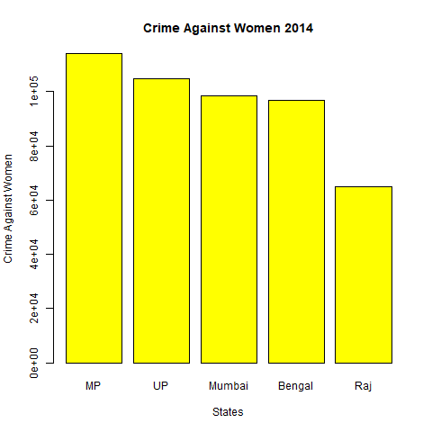

**Q5 -** **Age Group Wise Murder Victim.**

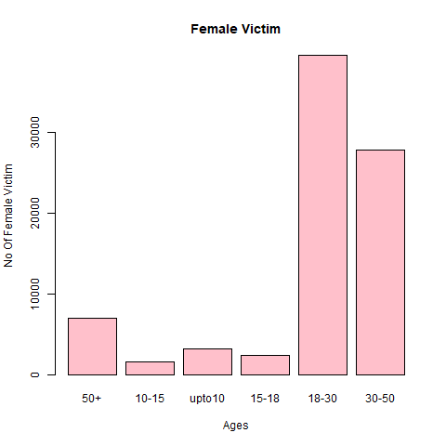

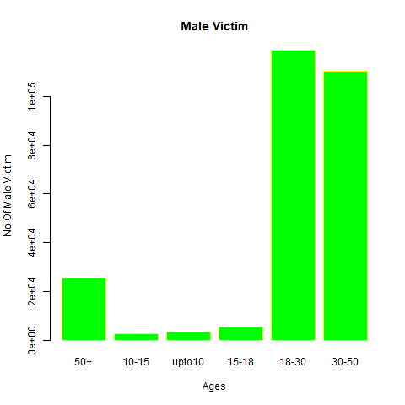

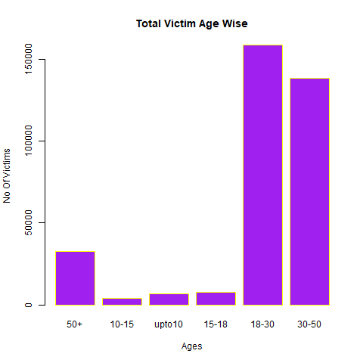

**Q6 - Crime By place of occurrence.**

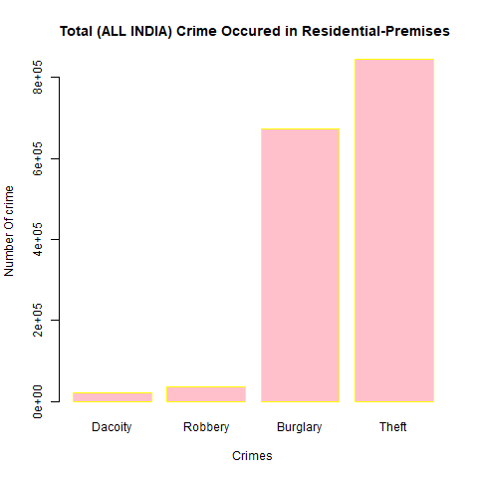

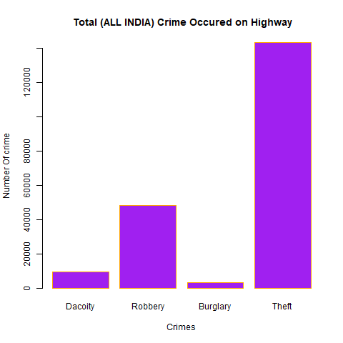

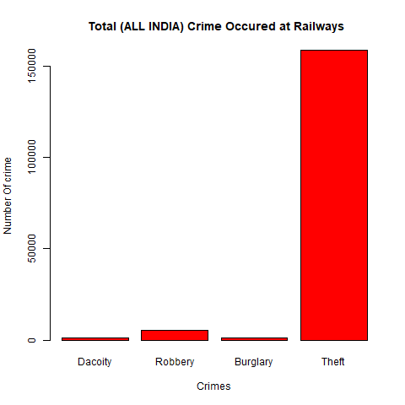

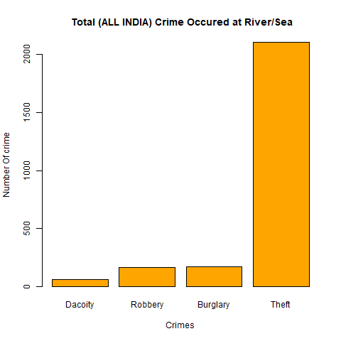

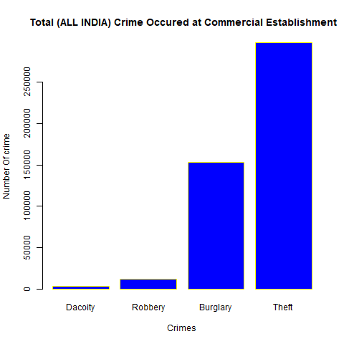

**Q7 - Which State has more complaints against police.**

UP has most numbers of complaints against police among all the states.

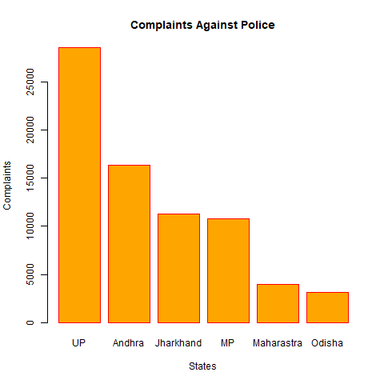

**Q8 - Which State Is the Safest for foreigner.**

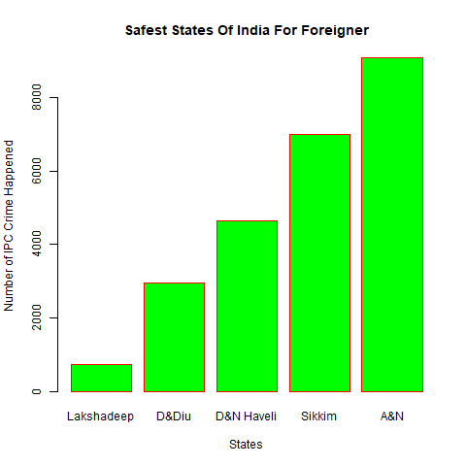

**LAKSHADEEP HAS THE LEAST NUMBER OF IPC CRIME LESS THAN 1000. SO MORE SECURE FOR FOREIGNER’S.**

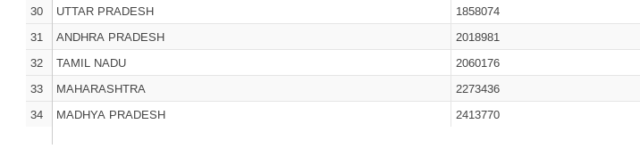

**MADHYA PRADESH HAS MOST NUMBER OF CRIME’S SO LEAST SECURE FOR FOREIGNER’S.**